Welcome to the Dubrovnik VR city tour!
The tour begins here at Pile Gate, the western entrance to the Old Town, and ends at Luža Square.
Dubrovnik has beenprotected as a UNESCO World Heritage Site since 1979.

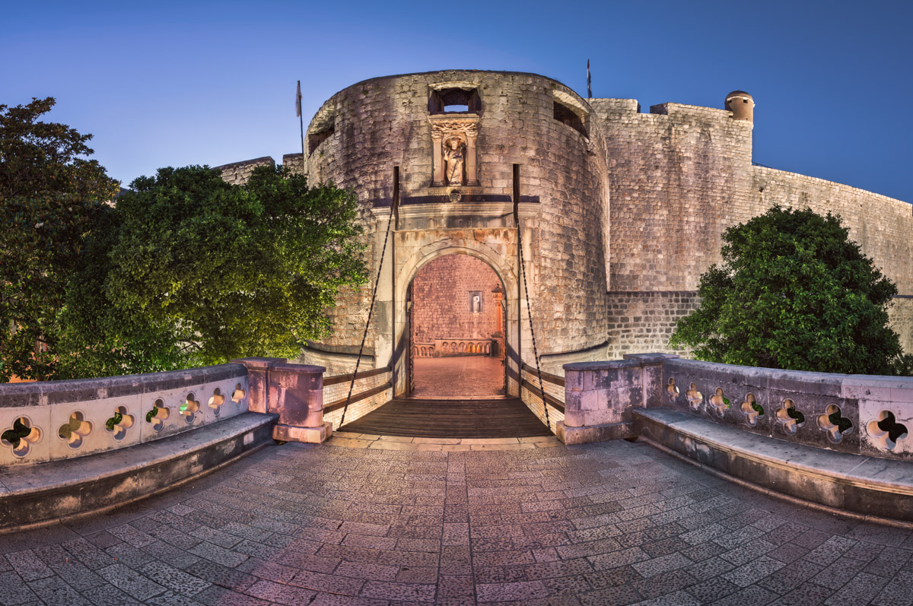

The foundation of Dubrovnik (historically known as Ragusa) dates back to the 7th century. The city was originally settled by refugees from the Roman city of Epidaurum (modern-day Cavtat) after it was destroyed by the Slavs.
Before we enter the Old Town surrounded by the city walls, have a look at the 400-metre-high SrđHill. This is where the Slavs founded their settlement at the beginning of the 7th century. It lay opposite the Roman village of Laus/Raus and was separated from it by a sea canal. When the two villages merged, the town was surrounded by walls and the canal filled in for easier communication.
The city developed rapidly during the medieval period and became an independent republic by the 14th century. Its wealth was primarily based on maritime trade. Dubrovnik's well-preserved city walls, architecture, and cultural heritage make it a UNESCO World Heritage Site today.
On top of SrđHill, one can visit the Napoleonic fortress Imperial, which houses the war museum dedicated to the war that Croatia led for independence in 1991.

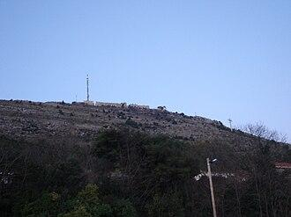

Onofrio’s Fountain

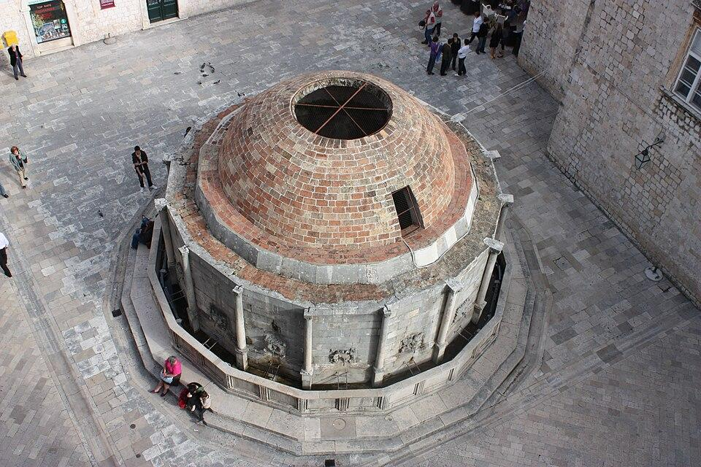

The fountain was designed by Onofrio della Cava from Naples, who also designed the smaller fountain at the other end of the main street called Placa or Stradun. The fountains were built for public use for the occasion of the completion of the water-supply system in 1438, whenspring water was brought from Rijeka Dubrovačka located 12 kilometres away.
The old water-supply system is today connected to the new waterworks system. The cupola of the monumental Onofrio's Fountain was damaged in the earthquake of 1667, and later reconstructions failed to restore its original form.

*Show entrance to the city walls.*

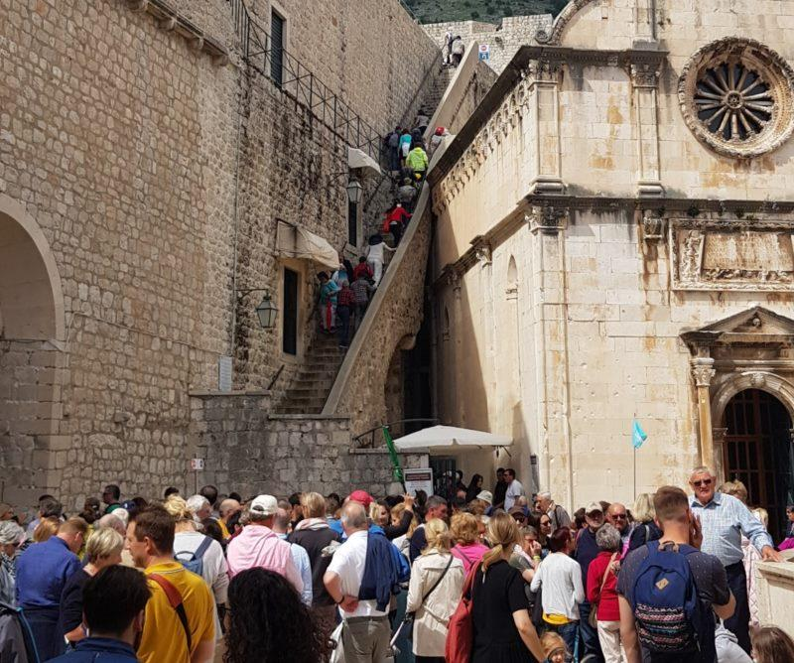

Franciscan Monastery

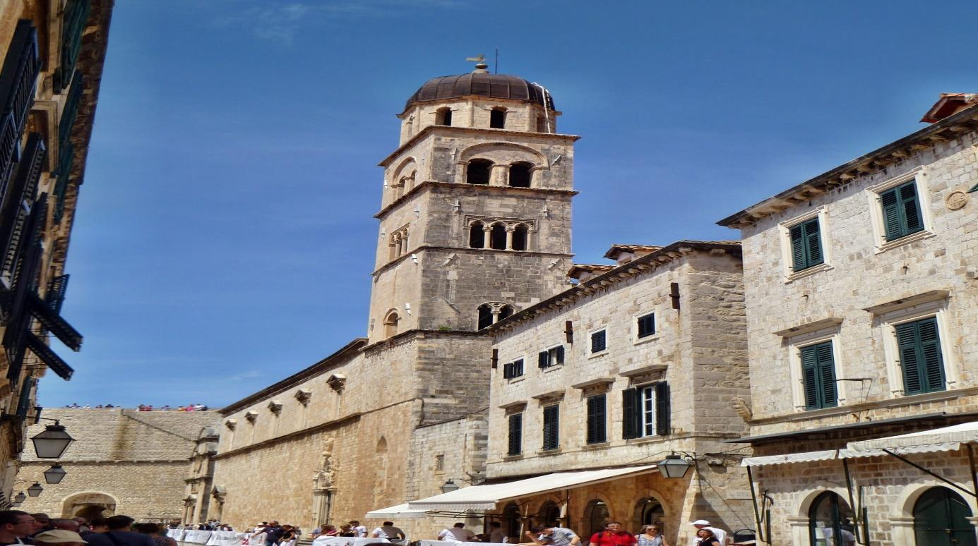

The Franciscan Monastery was founded in 1317 and stands as a symbol of the city’s religious and architectural heritage. It is part of a complex that includes a church, a museum, and a pharmacy - one of the oldest still functioning pharmacies in Europe.

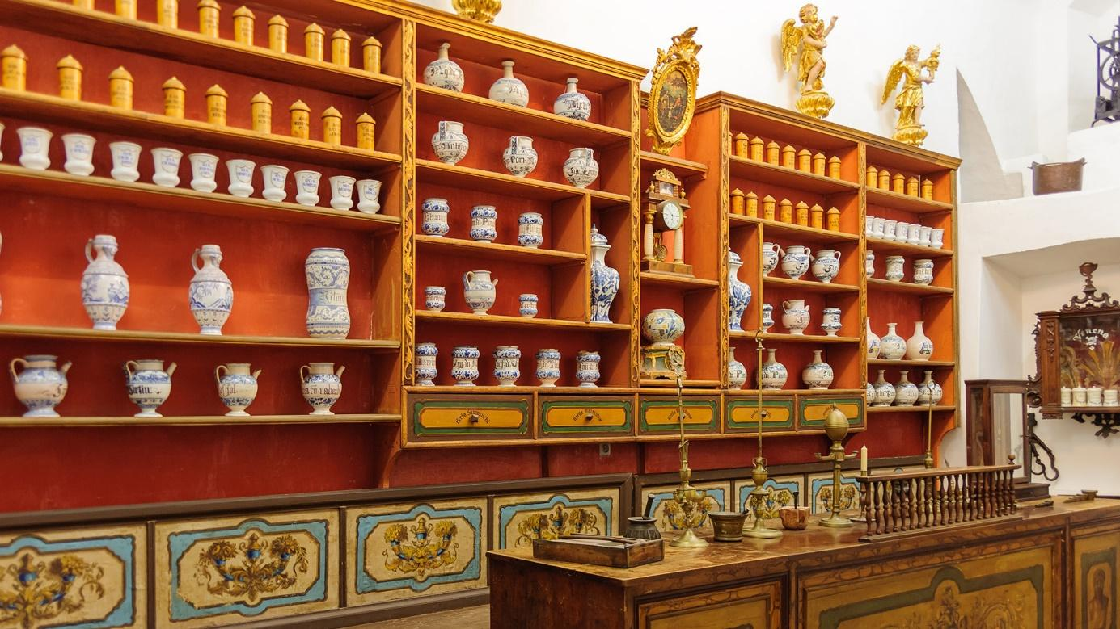

Stradun, officiallycalled Placa, is Dubrovnik's main street, stretching 300 meters from Pile Gate in the west to Luža Square in the east. Along this limestone-paved street, which cuts through the heart of the Old Town, there are many historical sights, restaurants, bars, cafés, and shops.

*Walk toŠiroka Street.*

Široka Streetis a picturesque and notably broad street located in the heart of Dubrovnik's Old Town. The street, today lined with numerous restaurants, cafés, and shops, was once an important thoroughfare providing quick access to the granary building located further up the street.
Take a look from Široka Street towards Stradun to see the houses which were all built under strict regulations after the earthquake that almost destroyed the town in 1667. All façades are simple and made of the same stone, while the top floor always houses the kitchen.

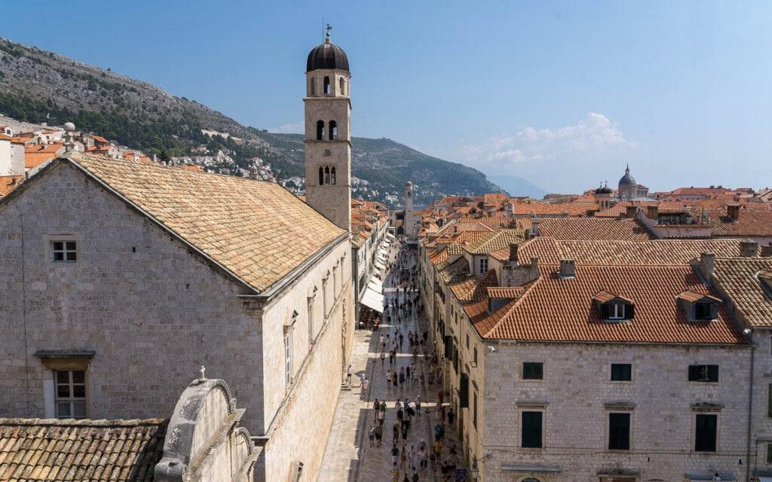

*Walk to Od Puča Street.*

The "Street of the Wells" or Od Puča Street runs parallel to the Placa (Stradun) along its entire length. It shows the cosmopolitan and multi-religious spirit of Dubrovnik. Along this street you can find Catholic, Orthodox and Islamic places of worship.The name of the street comes from the Slavic word "puč", meaning well. Many wells were scattered along the street. These wells (water tanks) collected rainwater and so supplied the common people of Dubrovnik with water.

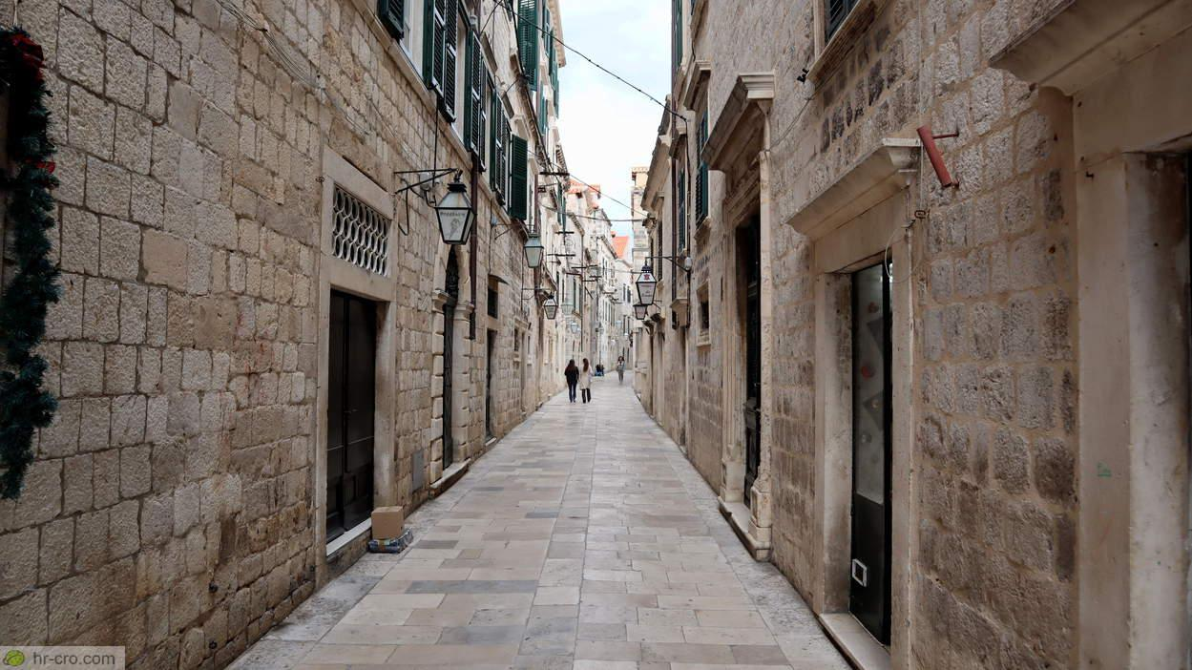

*ShowSaint Joseph's Church.*
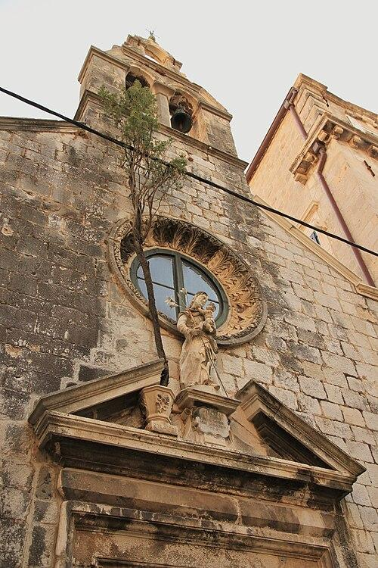

Saint Joseph's Church was built in 1668 on the site of an earlier church named StJames of Puča, which was originally built in 1299 and destroyed in theearthquake of 1667. The present day church of StJoseph has an elongated ground plan with no prominent apse. It is Baroque in style with Classical elements. The church of St Joseph was built by the brotherhood of carpenters. The façade, with a sculpture of St Joseph and a rosette, ends in a three-arched bell gable. This chapel is one of numerous little chapels within the city walls and the only one open for prayer 24/7. Its curiosity is a cypress tree that grows from the stone, further enhancing the charm of this small church.

Dubrovnik Synagouge

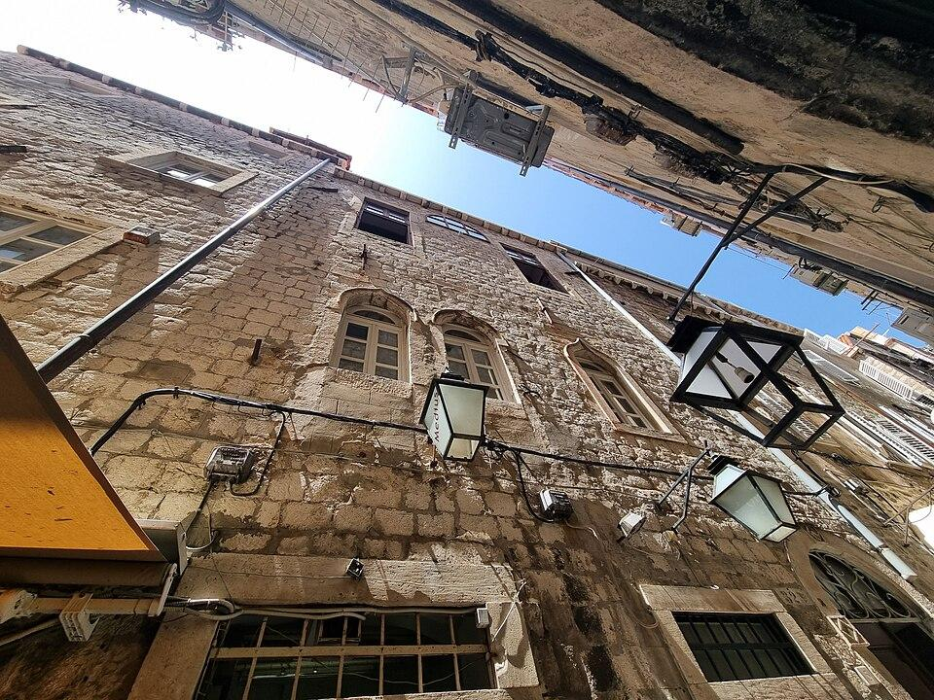

The Dubrovnik Synagogue, commonly called the Old Synagogue, is an Orthodox Jewish synagogue, located in Dubrovnik, Croatia. It is the oldest Sephardic synagogue still in use in the world and the second oldest synagogue in Europe. It is believed to have been established in 1352, but gained legal status in the city in 1408. Owned by the local Jewish community, the main floor functions as a place of worship for the High Holy Days and special occasions. Nowadays, it mainlyserves as a Jewish museum,which houses numerous ritual objects and centuries-old artefacts

Dubrovnik Islamic Community Majlis

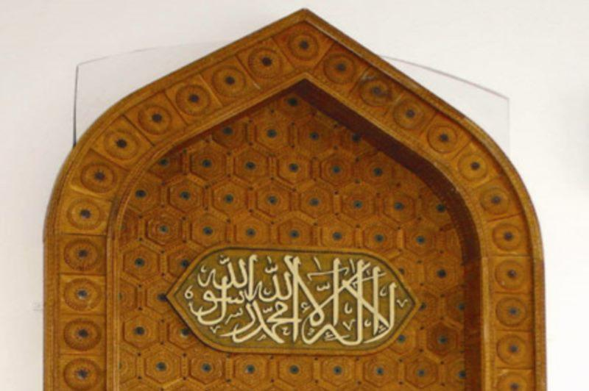

Muslims began to arrive in Dubrovnik only after 1878. The Community's seat is located in the Old City centre. The Islamic Community has its own premises,which include a Masjid (place of worship), offices, a Mektebi (religious instruction room), a library and a youth club.

The Church of the Holy Annunciation is a Serbian Orthodox church in Dubrovnik. It was built in 1877 and houses richly decorated iconostasis and the museum of icons.

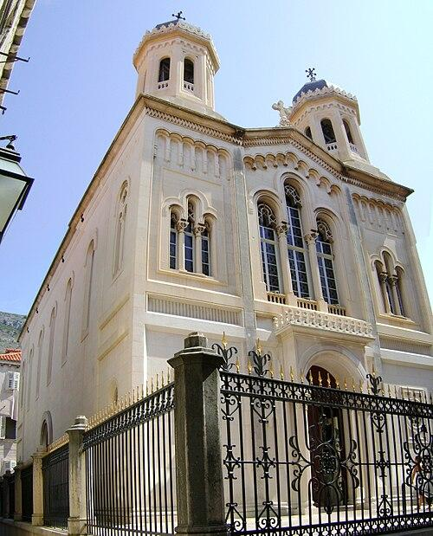

Od Puča Street is full of small shops, such as leather goods stores, handmade souvenir shops, jewellers and more, making it ideal for your shopping in Dubrovnik. The street connectsPaskoje Miličević Square with Onofrio’s Fountain and the Gundulić Square.

Orlando’s Column

At the center of LužaSquare stands Orlando’s Column.

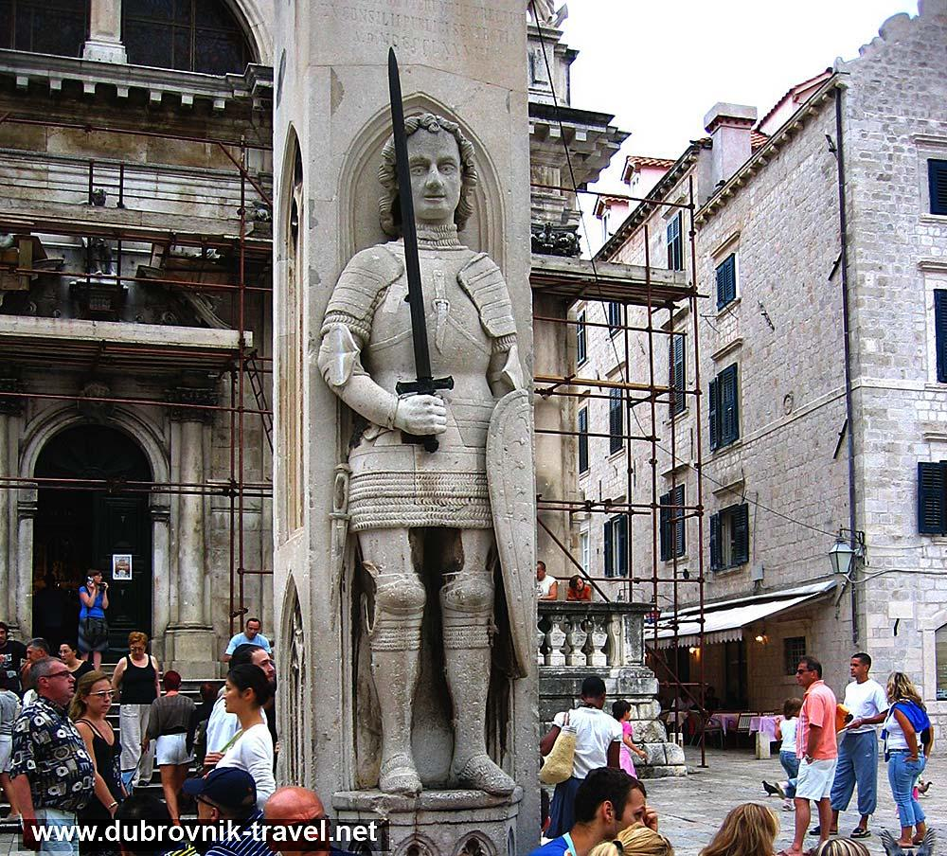

Erected in 1418, Orlando's Column, featuring the statue of this medieval knight in armour, stands in the square formed by Sponza Palace, St Blaise's Church and the BellTower. It represents Roland, an 8th century knight who became a legend through the medieval epic Chanson de Roland.
Although the statues of Roland were erected mainly in German cities, hislegend was likely brought to Dubrovnik in the 15th century by the Hungarian and Bohemian King Sigismund, the patron of the Dubrovnik Republic.
According to legend, Roland saved Dubrovnik from the Saracens, defeating them near the island of Lokrum. The white flag of the Dubrovnik Republic, bearingthe image of St Blaise and his initials SB, was flown on Orlando's Column until the abolition of the Republic in 1808.
Since the founding of the Dubrovnik Summer Festival in 1950, the square around Orlando’s Column has hosted the Opening Ceremony, during which the Festival flag with the symbolic inscription Libertas is raised on the Column.
Other notable landmarks on Luža Square include Sponza Palace, the Church of St Blaise, the Small Onofrio’s Fountain, the Rector’s Palace, and the Dubrovnik Bell Tower.

The Dubrovnik Bell Tower, located on Luža Square at the eastern end of Stradun, is 31 metres high.Originally constructed in 1444, the tower was damaged by earthquakes, especially by the 1667 earthqake, and, having started to lean towards Stradun in the early 19th century, was demolished in 1928and entirely rebuilt to the original design in 1929. It was damaged again in the 1979 Montenegro earthquake, and restored in 1987–1988. The bronze bell, which strikes the hours, was cast in 1506 by Ivan Rabljanin.

Luža Square, at the eastern end of Stradun, is one of Dubrovnik’s busiest and most historically significant central squares. It has been an important meeting point for centuries and is home to some of the city’s most significant landmarks, making it a must-visit spot in the Old Town. Here, public announcements, proclamations, and even executions once took place.

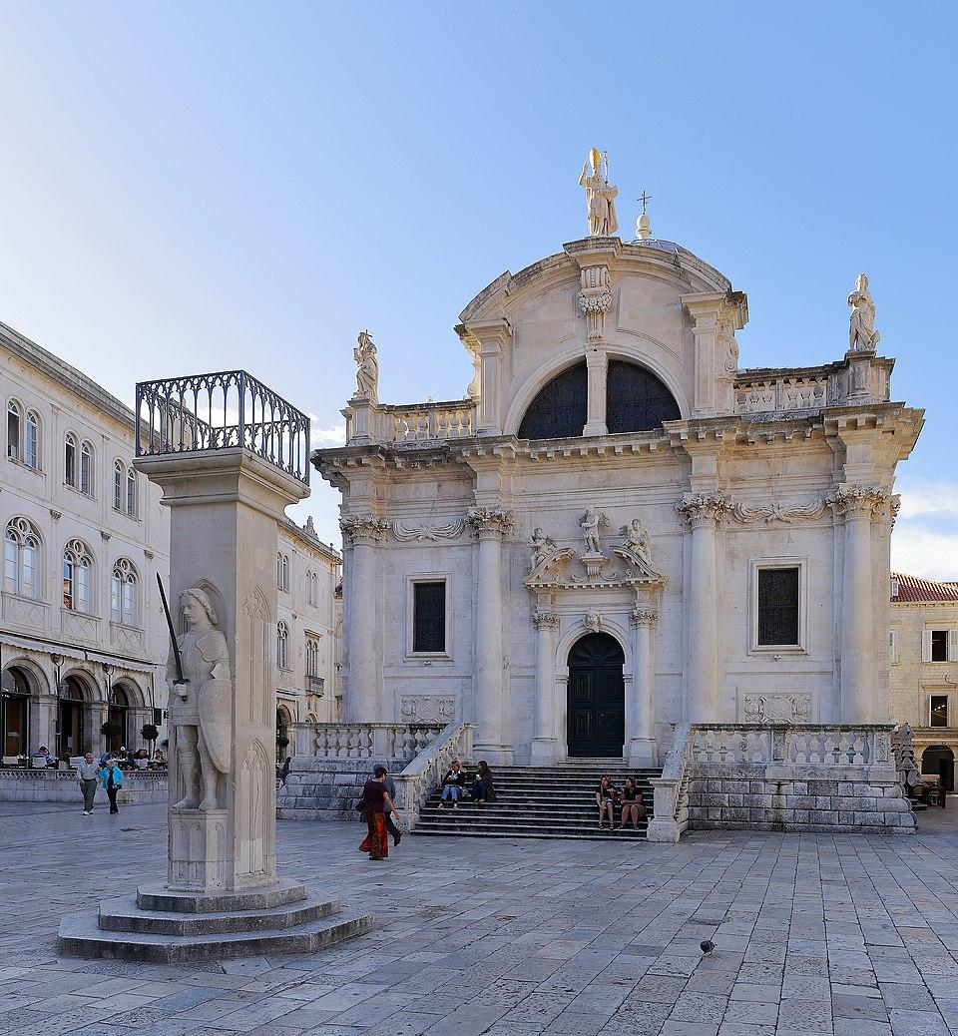

The Church of Saint Blaise is a Baroque church built between 1706 and 1714 on the site of a 14th-century Romanesque church damaged in the fire around 1680. The church features a wide staircase and terrace, which is a popular place to sit and watch the world go by.

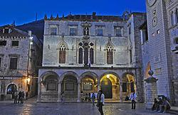Sponza Palace at dusk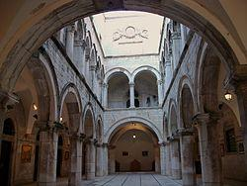The atrium of the palace

The Sponza Palace, also called Divona (from dogana, meaning customs), is a 16th-century palace in Dubrovnik's Old Town. Its name is derived from the Latin word "spongia", the place where rainwater was collected.The rectangular building with an inner courtyard was built in a blend of Gothic and Renaissance styles between 1516 and 1522 by Paskoje Miličević Mihov, who also worked on the City walls. The loggia and sculptures were crafted by the brothers Andrijić and other stonecutters.The palace has served a variety of public functions, including as a customs office and bonded warehouse, mint, armoury, treasury, bank and school. It became the cultural center of the Republic of Ragusa with the establishment of the Academia dei Concordi, a literary academy, in the 16th century. It survived the 1667 earthquake with almost no damage. The palace's atrium served as a trading center and business meetingplace. A Latin inscription on one of its arches testifies to this public function:
Fallere nostra vetant et falli pondera. Meque pondero cum merces ponderat ipse deus.
"Our weights do not permit cheating. When I measure goods, God measures with me."

The palace is now home to the Dubrovnik State Archive, which holds documents dating back to the 12th century, the earliest being from 1022. These files, including more than 7000 volumes of manuscripts and about 100,000 individual manuscripts, were previously kept in the Rector's palace.The Luža Square in front of the palace is used for the opening ceremony of the Dubrovnik Summer Festival, and Sponza Palace itself is also used as a performance venue.

Small Onofrio's Fountain

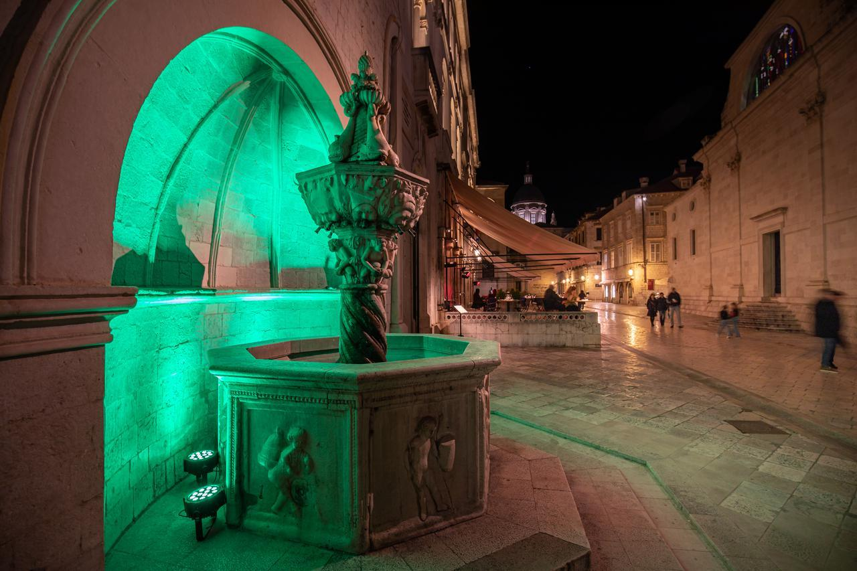

Located at the eastern end of Stradun near Luža Square, the historic Small Onofrio’s Fountain is an ornately decorated octagonal fountain. The small fountain, often overlooked by tourists, played an essential role in the history of Dubrovnik’s watersupply. The Italian architect Onofrio della Cava designed and constructed the fountain between 1440 and 1442. He also created the Large Onofrio’s Fountain located near Pile Gate. Pietro di Martino from Milan handled the sculpting work.The eight-sided fountain sits in a semi-circle arched niche of the City Guard Building. Ornate carvings include playful children, dolphins, and shells.Its Gothic and Renaissance elements and reliefs are a fine example of the city’s artistic and architectural innovation at the time.Though small, the fountain played a significant role in Dubrovnik’s medieval water-supply system, providing water to buildings (including the Rector’s Palace), nearby markets, and to the citizens of the city.Today, the Small Onofrio’s Fountain still supplies fresh drinking water to locals and tourists who pass by for a refreshing drink on a hot day.

Rector's Palace

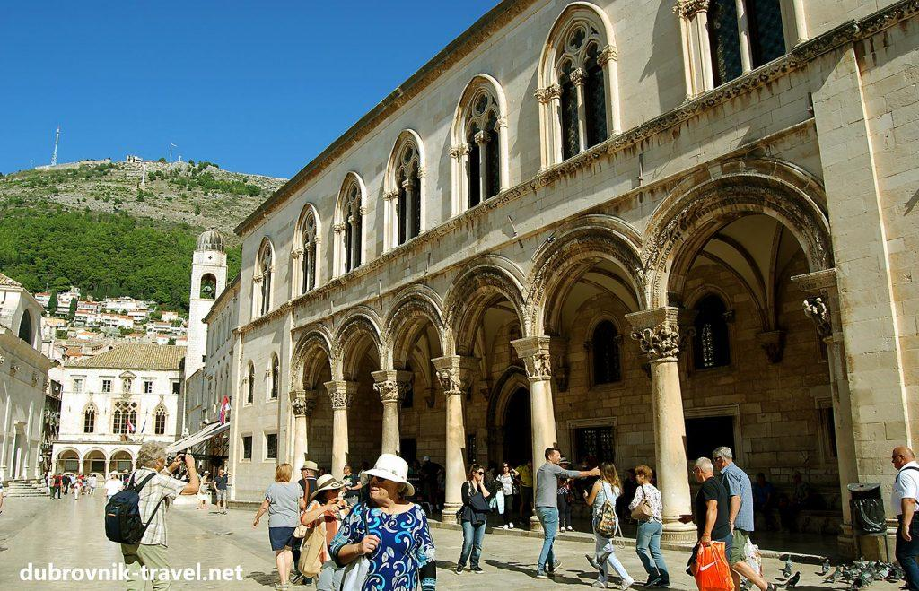

The Rector's Palace was the administrative centre of the Dubrovnik Republic. Its style is predominantly Gothic, with Renaissance and Baroque reconstructions.In the 15th century, the Palace was destroyed twice in gunpowder explosions. Restored by Onofrio della Cava in the late Gothic style after the first explosion in 1435, the Palace got its present-day size with the central atrium and front portico.
The capitals were carved in Renaissance style by Pietro di Martino of Milan, whose capital with Aesculapius has been preserved on the right half-column of the portico. The second gunpowder explosion in 1463 destroyed the western facade of the Palace, and two famous architects, Juraj Dalmatinac and Michelozzo of Florence, were engaged in the reconstruction for a short period.Although the design of Michelozzo was unfortunately rejected, his influence in the restoration of the facade and portico, mainly in the Renaissance style, cannot be denied. After the earthquake of 1667, the atrium was partially reconstructed with an impressive Baroque staircase.
During his one-month mandate, the Rector of Dubrovnik lived in the Palace, which also housed the Minor and Major Council hall, the Rector's residence, the courtroom, administration office, prisons, an arsenal and gunpowder store-house. The Great Council Palace was also destroyed by the explosion, and in its placeThe City Hall and theater were built during the 19th century.

Dubrovnik Cathedral

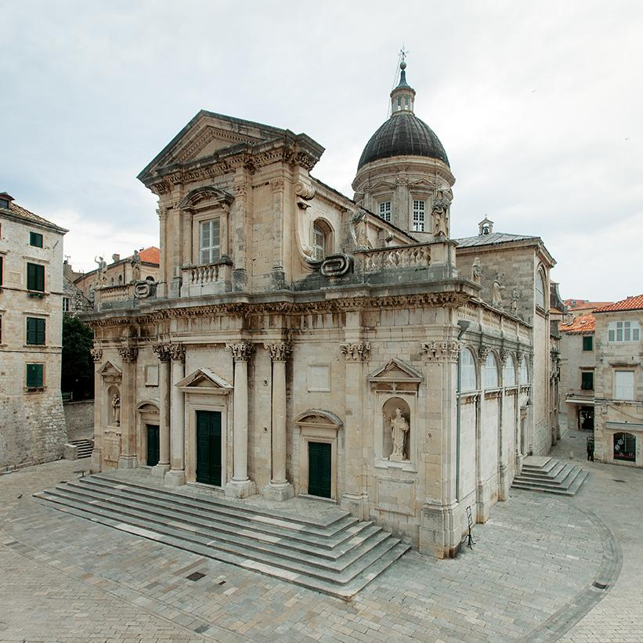

The cathedral dates back to the late 1100s, when King Richard the Lionheart of England survived a nearby shipwreck anddonated funds for its construction. However, much of what you currently see is dated from after the catastrophic earthquake of 1667, which destroyed most of the original building.
Visitors are welcome to sit quietly inside the cathedral and enjoy the peaceful atmosphere.

The Jesuit Stairs

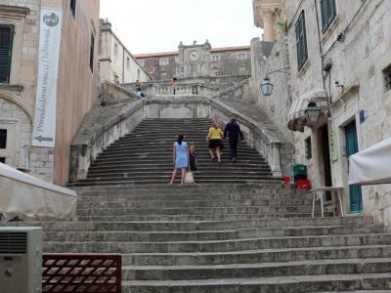

The Jesuit Stairs are a grand Baroque staircase that connects Gundulić Square to the Church of St Ignatius in the Old Town of Dubrovnik.The Church of St Ignatius, located at the top of the stairs, is an old church that once belonged to Collegium Ragusinum, a Jesuit college in Dubrovnik. The stairs are considered to be one of the city’s most notable examples of Baroque architecture.Most visitors to Dubrovnik know the Jesuit Stairs from the TV show Game of Thrones. In the famous “Walk of Shame” episode, Cersei Lannister walks naked down the stairs as if in public humiliation. The scene has made the stairs a must-visit for all fans of the show.

Behind the Cathedral lies Dubrovnik's Old Port.

Surrounded by mighty city walls, the port was once the main entry point for goods and visitors - and at times, enemies -of Dubrovnik. For the purpose of defending the port, St John’s Fort was built as a part of thecity's defense system. Additionally, chains were installed between the fort, breakwater known asKaše, and the church of St Luke. Today, the fort houses the MaritimeMuseum and the Aquarium.

